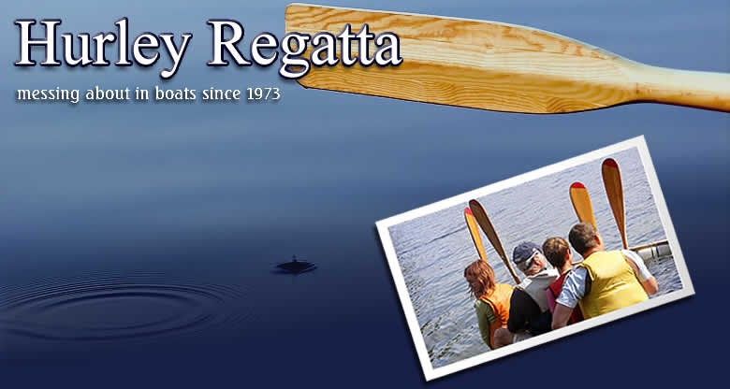

The Committee of the Hurley Regatta (the Committee) organises an annual regatta on the river Thames which is a great day out for the local community and which raises money for worthwhile causes. To enable us to organise and run the Regatta, the Committee collects and holds personal data. The Committee is committed to protecting and respecting any personal data you share with us. This statement describes what information we collect from you, how it is used by us, how we share it with others, how you can manage the information we hold and how you can contact us.

The contents of this statement may change from time to time so you may wish to check this page occasionally to ensure you are still happy to share your information with us.

Your personal data – what is it?
Personal data relates to a living individual who can be identified from that data. Identification can be by the information alone or in conjunction with any other information in the data controller’s possession or likely to come into such possession. The processing of personal data is governed by the Data Protection Act 1998 and by the General Data Protection Regulation (GDPR) from May 25 2018.

If you are under 18 years old please talk with either a parent and/or legal guardian before providing any data.

Who are we?
The Committee of the Hurley Regatta is the data controller (contact details below). This means it decides how your personal data is processed and for what purposes. The Committee is committed to protecting and respecting any personal data you share with us.

How do we process your personal data?
Hurley Regatta complies with its obligations under the “GDPR” by keeping personal data up to date; by storing and destroying it securely; by not collecting or retaining excessive amounts of data; by protecting personal data from loss, misuse, unauthorised access and disclosure and by ensuring that appropriate technical measures are in place to protect personal data.

The data we collect about you includes some or all of the following: Name (including title)
Address Phone number Email address Date of Birth

We use your personal data for the following purposes:
- To enable us to run an annual regatta which is an enjoyable local community event and which raises money to be donated to a local charity;
- To administer individual sponsor records;
- To communicate with and manage our volunteers (including members of the various sub-Committees);
- To communicate with and administer individual entrants to the regatta;
- To communicate with and administer individuals who may be suppliers, stall holders and / or advertisers;
- To communicate with individuals at the charities we support
- To maintain our own accounts and records;
- To inform you of news, events, activities relating to the regatta.

Date of Birth – when completing an online booking form you may be asked to supply the date of birth for an entrant in a race to confirm that they meet the age requirements. Please note we do not need the entrant’s full legal name or other identifying data, so please don’t include this on the form.

What is the legal basis for processing your personal data?
- For Committee members, individual sponsors, raffle prize donors and volunteers we rely on your explicit consent as the data subject, so that we can keep you informed about news, events and activities relating to the regatta.
- For individual entrants to the regatta who enter via the website, or at the entrants’ tent on the day, we rely on your explicit consent as the data subject, given by your providing the data via the website or at the entrants’ tent, so that we can keep you informed about news, events and activities relating to the regatta.
- If you give us information on behalf of someone else (e.g. as an entrant), you’re confirming that you’ve given them the information in this policy, and that they’ve agreed for us to use their information
- For people who give us their data e.g. when they purchase raffle tickets, we rely on your explicit consent
- For individual suppliers, stall holders and advertisers we rely on your having contracted with us to provide and / or receive a service at the regatta

- For individuals at the charities we support we rely on this being in our legitimate interests

Sharing your personal data
Your personal data will be treated as strictly confidential and will only be shared with other committee members and others involved with the Regatta to enable us to manage the regatta.

For example, we may create a gate rota showing the names of all the volunteers for the gate and the times they will be covering, which may be shared with all the gate volunteers and the committee members.

We will not share your data with third parties outside of the regatta without your consent. However we do include the names of many of our Committee members, volunteers, sponsors, raffle prize donors and entrants in the published regatta programme which is available to others.

How long do we keep your data?
We will not hold your personal data for any longer than is necessary.

  - Names and contact information for committee members is kept whilst they are on the committee.
  - Names of individual sponsors, individual raffle prize donors, many of our volunteers and entrants are included in the regatta programme. We aim to keep copies of past programmes permanently.
  - Names and contact details of individual sponsors, individual raffle prize donors and volunteers are kept indefinitely so we can contact you in future years to contribute to the Regatta again.
  - Names and contact information of people completing the entry form is kept for 3 years
  - For people who give us their data e.g. when they purchase raffle tickets, we will keep your data until the raffle has been drawn and prizes claimed.
  - For individual suppliers, stall holders and advertisers we will keep your data for up to 7 years after the date of the relevant regatta as part of our financial records.
  - For individuals at the charities we support we will keep your data for up to 7 years after the date of the relevant regatta as part of our financial records and so that we may contact you again about potential donations.

Your rights and your personal data
Unless subject to an exemption under the GDPR, you have the following rights with respect to your personal data:
  - The right to request a copy of your personal data which the Committee holds about you;
  - The right to request that the Committee corrects any personal data if it is found to be inaccurate or out of date;

  - The right to withdraw your consent (where we rely on this per section 4 above) to the processing at any time;
  - The right to object to the Committee’s use of your information (where we rely on legitimate interests to use your personal information) provided we do not have any continuing lawful reason to continue to use and process the information;
  - The right to request your personal data is erased where it is no longer necessary for the Committee to retain such data provided we do not have any continuing lawful reason to continue to use and process the information;
  - The right to request that the data controller provide the data subject with his/her personal data and where possible, to transmit that data directly to another data controller, (known as the right to data portability), (where applicable)
  - The right, where there is a dispute in relation to the accuracy or processing of your personal data, to request a restriction is placed on further processing;
  - The right to lodge a complaint with the Information Commissioners Office.

You can exercise the above rights and/or manage your information by contacting us as per section 9

Further processing
If we wish to use your personal data for a new purpose, not covered by this Data Privacy Notice, then we will provide you with a new notice explaining this new use prior to commencing the processing and setting out the relevant purposes and processing conditions. Where and whenever necessary, we will seek your prior consent to the new processing.

Contact Details

To exercise all relevant rights, queries or complaints please in the first instance contact the Committee as follows:

In writing to the Chairman at:
Jay Dodson
Unit 557
105 London Street
Reading
RG1 4QD

Or by email to: HurleyRegattaChair@gmail.com

If you are unhappy, you have the right to lodge a complaint with the data protection regulator in the UK whose contact details are:

Post: | Customer Contact
 | Information Commissioner’s Office
 | Wycliffe House
 | Water Lane
 | Wilmslow
 | Cheshire
 | SK9 5AF
Call: | 0303 123 1113
Email: | casework@ico.org.uk

Cookies on our Website

We do not use cookies on our website.

Review of this Policy
This policy was agreed in March 2023 and will be reviewed and if necessary, updated, every 3 years.

